Multiplication of Integers
Multiplication of two integers is the repeated addition.
Example
- 3 × (-2) = three times (-2) = (-2) + (-2) + (-2) = – 6
- 3 × 2 = three times 2 = 2 + 2 + 2 = 6
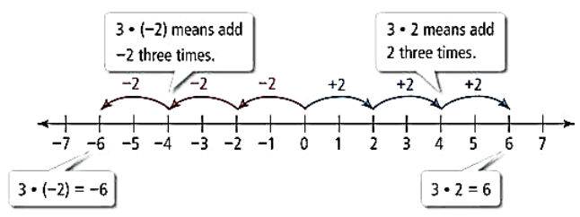
Now let’s see how to do the multiplication of integers without the number line.

1. Multiplication of a Positive Integer and a Negative Integer
To multiply a positive integer with a negative integer, we can multiply them as a whole number and then put the negative sign before their product.
So the product of a negative and a positive integer will always be a negative integer.

For two integers p and q,

p × (-q) = (-p) × q = - (p × q) = - pq

Example
4 × (-10) = (- 4) × 10 = - (4 × 10) = - 40
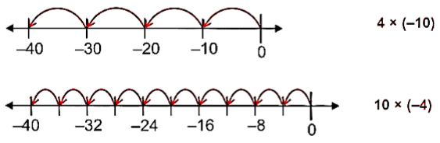

2. Multiplication of Two Negative Integers
To multiply two negative integers, we can multiply them as a whole number and then put the positive sign before their product.
Hence, if we multiply two negative integers then the result will always be a positive integer.

For two integers p and q,

(-p) × (-q) = (-p) × (-q) = p × q

Example
(-10) × (-3) = 30

3. The Product of Three or More Negative Integers
It depends upon the number of negative integers.
a. If we multiply two negative integers then their product will be positive integer
(-3) × (-7) = 21
b. If we multiply three negative integers then their product will be negative integer
(-3) × (-7) × (-10) = -210
If we multiply four negative integers then their product will be positive integer
(-3) × (-7) × (-10) × (-2) = 420
Hence, if the number of negative integers is even then the result will be a positive integer and if the number of negative integers is odd then the result will be a negative integer.

Rules for multiplication and division of integers
